# Webots – Damian Pang

Device Specifications:

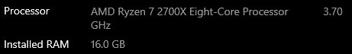



Running windows 10 home 64-bit

Due to Covid-19 and the nation going into lockdown. Myself and my team were unable to work on farm-bot, which required us to go onto campus. Because of these circumstances, we were asked to look at Webots, which is an open source 3D robot simulator. Unfortunately, no matter what I tried I could only get the black screen showed below, and I was unable to carry out any testing of the simulator. I tried a variety of potential fixes such as uninstalling and re-installing, resetting the project and saving then re-opening and I was unable to get the black screen.

